Parth Chandgadhiya

In Class Assignment 3

SETAS/ICET

COMP 316

Identify Defect Status

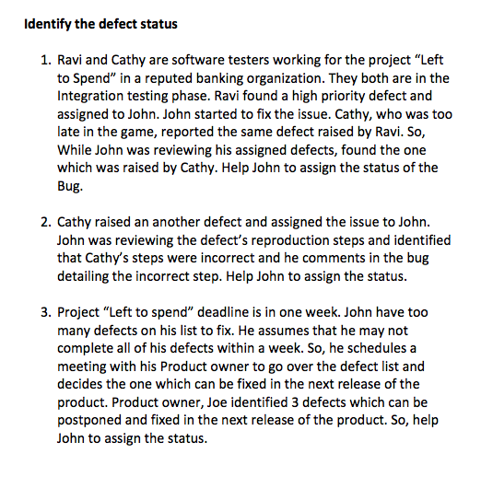

Answer 1:

## Duplicate

Answer 2:

## Rejected

Answer 3:

## Deferred

# Identify Severity of Defects

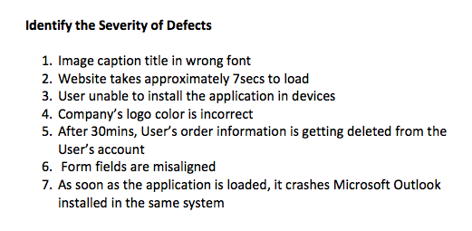

Answer 1:

## Severity: Low Priority: Low

Answer 2:

## Severity: Medium Priority: Medium

Answer 3:

## Severity: High Priority: High

Answer 4:

## Severity: Low Priority: High

Answer 5:

## Severity: Medium Priority: High

Answer 6:

## Severity: Low Priority: Low

Answer 7:

## Severity: High Priority: High